2D

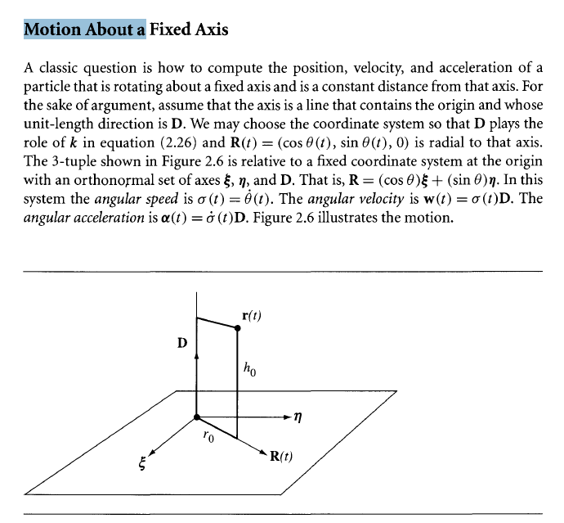

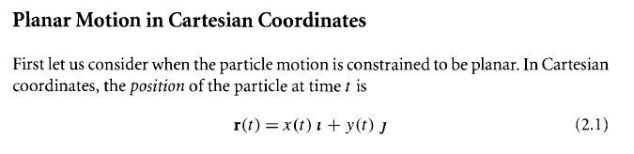





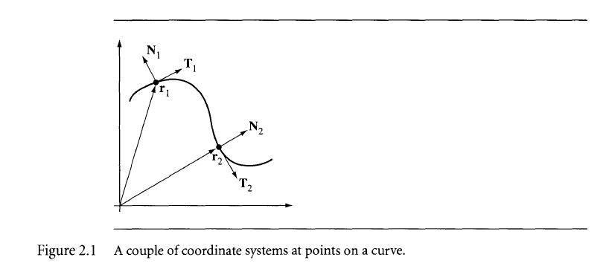

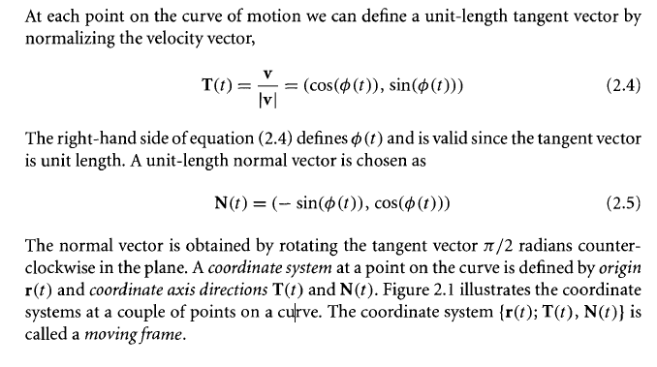

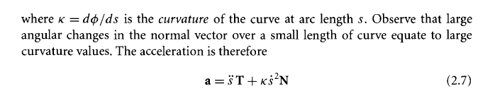

3D





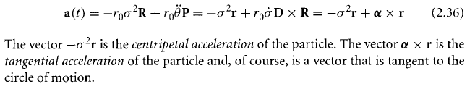

Identify Contact set

Vertex-face

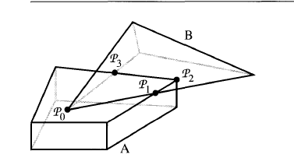

Let P0 be the contact point. If the point is a vertex-face intersection,

So we get B’s vertex and A’s face

N be the normal for the face



v is the velocity of the center of mass

w is the angular velocity of the body about its center of mass

r is the location of the point relative to the center of mass

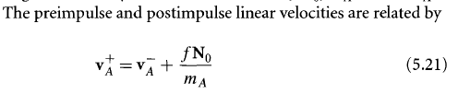

The linear momentum is 

But the impulsive force also has a contribution that changes the angular velocity of the body via an impulsive torque, , where JA is the inertia tensor at the contact time

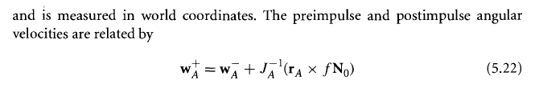

Edge-edge (when not parallel)

Edge-face